Ideation Phase
Define the Problem Statements

Date | 11 September 2026
Team ID | NA
Project Name | Metro Ticket Generating System in ServiceNow
Maximum Marks | 2 Marks

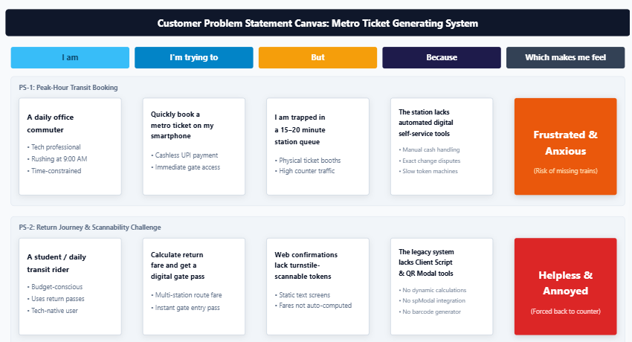

Problem Statement (PS) | I am (Customer) | I’m trying to | But | Because | Which makes me feel
PS-1 | A daily office commuter rushing to board the metro during peak morning hours | Quickly purchase my metro transit ticket using UPI on my smartphone | I get stuck in physical ticketing queues for 15 to 20 minutes | Stations still rely on manual token dispensing booths and cash counters that cause massive bottlenecks | Frustrated and anxious about missing my train and being late to work
PS-2 | A student traveling across interchange lines with return journey requirements | Book a return trip ticket online in advance and know my exact route fare | I face manual fare calculation errors and end up with static web text receipts that turnstile gates cannot scan | The booking system lacks automatic route-to-fare scripting and does not issue portable, dynamic 2D barcodes | Helpless and annoyed by the lack of scannable, paperless gate access

